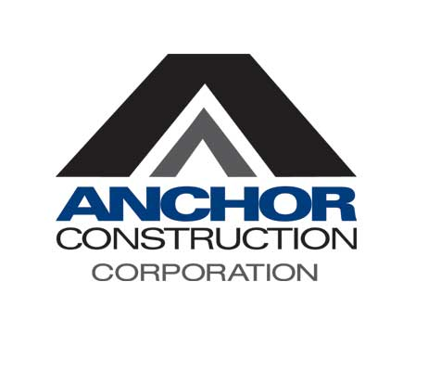

Job Description

Title: HR Generalist
Department: Human Resources
Job Status: Exempt
Location: Lanham, Md.
Reports to: Human Resources Sr. Director

Summary: Anchor Construction Corporation has an opening for a full-time Human Resources Generalist with relevant experience working within a 400+ employee organization. Anchor Construction is experiencing significant growth and as an HR team, we are modernizing and delivering our services in new and creative ways to match this growth. This role is part of a broader HR team charged with designing and executing a HR strategy that is driving the broader Anchor Construction business objectives. The ideal candidate will have prior experience working within a mature HR environment as well as experience supporting talent acquisition. The ideal candidate will possess strong relationship management skills. Fluency in English and Spanish is highly desired for this position.

Duties & Responsibilities:

Recruitment
- Conduct job postings on relevant job recruitment and social media sites.
- Coordinate and collaborate with external recruitment agencies.
- Plan and coordinate company hiring events.
- Attend job fairs (schools, colleges, trade associations, government-sponsored).
- Administer the company’s Applicant Tracking System.
- Review and select resumes for circulation to hiring managers for evaluation.
- Conduct phone screenings.
- Organize interview schedules with hiring managers.
- Coordinate drug screenings and background checks.
- Disposition candidates in the Applicant Tracking System.
- Extend offers of employment to selected candidates under the direction of the hiring managers and within the guidelines of company compensation structure.
- Manage and coordinate all communication with candidates.
- I-9 verification
- Track new hire paperwork.

HR Support
- Coordinate and participate in new hire orientation.
- Make updates to employee records in the company’s HRIS, including hires, benefit enrollments, terminations, etc.
- Submit monthly hiring/termination reports to the executive team.
- Support HR Manager with employee relations issues.
- Respond to HR related inquiries from employees in a timely fashion.
- Support other HR team members with managing/maintaining employee records and files.
- Assist with employee benefits administration and Open Enrollment.

Qualifications:

- Bachelor’s degree from a four-year college or university highly desirable.
- 4-5 years’ experience in progressively responsible human resources roles; recruiting experience in the construction industry highly desirable.
- Bilingual in English and Spanish highly preferred.
- Proficiency with Microsoft Office, and experience with HRIS programs.
- Strong knowledge and application of full life-cycle recruiting.
- Strong communication skills, ability to build strong relationships internally and externally with candidates and hiring managers.
- Excellent organizational and time-management skills with the ability to prioritize tasks
- Ability to handle multiple hiring needs and adapt to changing priorities.
- Excellent sourcing skills including public resume databases (LinkedIn, Indeed, etc.)
- Excellent verbal and written communication skills in English and Spanish strongly desired.
- Ability to act with integrity, professionalism, and confidentiality crucial.
- Ability to work overtime as needed.
- Ability to work effectively with minor supervision.

Anchor Construction is an equal employment opportunity employer. All qualified applicants will receive consideration for employment without regard to race, color, religion, gender identity or expression, national origin, disability status, protected veteran status or any other characteristic protected by law.

