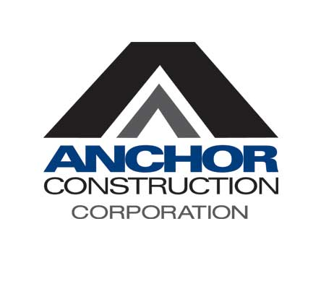

Job Description

Title: Heavy Equipment Operator (DC Operator License)
Department: Field Operations
Job Status: Non-Exempt
Location: Various locations including the Metropolitan DMV and Eastern Shore
Reports to: Foreman/Superintendent/Dispatch

Summary: Operates a variety of equipment and trucks used in construction, maintenance and repair activities and performs a variety of semiskilled tasks in the maintenance of underground utilities.

Primary Duties & Responsibilities:
- Ensure a safe work environment in compliance with OSHA, State regulations, and all safety policies and procedures
- Report any problems and/or safety hazards to your foreman or, in their absence the crew lead or Superintendent or Safety Officer
- Use skills acquired through years of experience, excavates through sand, soil, dirt, rock, and earth
- Able to read and understand plans and blueprints
- Knows how to navigate equipment within city confines, around utilities
- Safely operate equipment using all features and functions
- Be willing to be a team player

Secondary Duties & Responsibilities:
- May assist Foreman with assignments while on site
- May perform other duties as assigned by Dispatch, Superintendents and/or Foremen
- Inspect equipment daily and fill out daily equipment log

Required Qualifications:
- Experience operator an Excavator and Backhoe, Skid Steer Loader
- Ability to navigate through utilities and operate equipment in a city
- Maintain and abide by all safety requirements
- Ability to follow basic instructions in English
- Ability to work overtime as needed
- Ability to work outdoors in various weather conditions
- Has DC Operator’s License
- Ability to pass physical exam ex. DOT
- Ability to travel to various work locations including work outside the region
- Must inspect equipment prior to start of work including greasing as required by manufacturer.
- Must be willing to drive rubber tire equipment from yard to various work locations
- May be required to wear special clothing

Physical Demands
Heavy
Expected to lift up to 120 pounds with frequent lifting/carrying objects

Work Environment
Moderate
Occasionally exposed to extreme atmospheric conditions (temperature, noise fumes, dust, etc.)
Exposed to the outdoor elements (cold, heat, rain, snow, etc.)
Noise level is loud

Anchor Construction is an Equal Employment Opportunity/Affirmative Action Employer. All qualified candidates will receive consideration for employment without regard to race, color, religion, sex, gender identity, sexual orientation, national origin, disability, protected veteran status or any other characteristic protected by law.

By signing below, I acknowledge that I have received a copy of this job description for Heavy Equipment Operator. I further acknowledge that I am able to perform the duties and handle responsibilities of the position with or without reasonable accommodations.

Note: Please note that this job description is not designed to cover or contain a comprehensive listing of activities, duties, or responsibilities that are required of the employee for this job. Duties, responsibilities, and activities may change at any time with or without notice.

___________________________________ ______________________________
Signature Date

